**Title: Estimation of pharmacokinetic parameters in clinical trials.**

Q.1 For data given below plasma concentration versus time calculate pharmacokinetic parameters Cmax, tmax by graphical method, and Ke , t1/2 by formula.

|  |  |
| --- | --- |
| Time (Hour) | Plasma Concetration (mcg/mL |
| 0 |  |
| 1 | 133 |
| 2 | 117 |
| 3 | 104 |
| 4 | 92 |
| 5 | 82 |
| 6 | 73 |

Q.2 For the given data below: Calculate AUC(0-32), AUC(0-∞), Cmax ,tmax ,Ke ,t1/2

|  |  |
| --- | --- |
| Time (Hour) | Plasma Concetration (mcg/mL |
| 0 | 0 |
| 0.5 | 0 |
| 1 | 2.8 |
| 1.5 | 4.4 |
| 2 | 4.4 |
| 3 | 4.7 |
| 4 | 4.1 |
| 6 | 4 |
| 8 | 3.6 |
| 12 | 3 |
| 16 | 2.5 |
| 24 | 2 |
| 32 | 1.6 |

* **Cmax**: The maximum value of plasma concentration.
* **tmax**: The time at which plasma concentration is maximum.
* **Ke** : Rate of elimination of the drug. (Ke = slope * (-2.303))
* **t1/2** : The time at which half of the drug is eliminated from the body. (t1/2 = 0.493/Ke)
* **AUC**: Area under the curve and AUC(0-k) = $∑\frac{\left(Ci−1\right)+(Ci) }{2}×(ti−t(i−1))$

AUC(0-∞) = AUC(0-k) + $\frac{Ck}{Ke}$

**> ### Q1** **Q.1 For data given below plasma concentration versus time calculate pharmacokinetic parameters Cmax, tmax by graphical method, and Ke , t1/2 by formula.**

|  |  |
| --- | --- |
| **Time (Hour)** | **Plasma Concetration (mcg/mL** |
| **0** |  |
| **1** | **133** |
| **2** | **117** |
| **3** | **104** |
| **4** | **92** |
| **5** | **82** |
| **6** | **73** |

**> t=c(0,1,2,3,4,5,6)**

**> p=c(0,133,117,104,92,82,73)**

**> m=1**

**> n=1**

**> t1=c(m,n)**

**> p1=c(min(p),max(p))**

**> cmax=max(p)**

**> cmax**

**[1] 133**

**>**

**> # Plotting data to identify Cmax(max concentration) and tmax(max time)**

**> plot(t,p,main="graph for Tmax",lty=2,lwd=2,type="l")**

**> lines(t1,p1,"o",lty=3,lwd=2)**

**>** 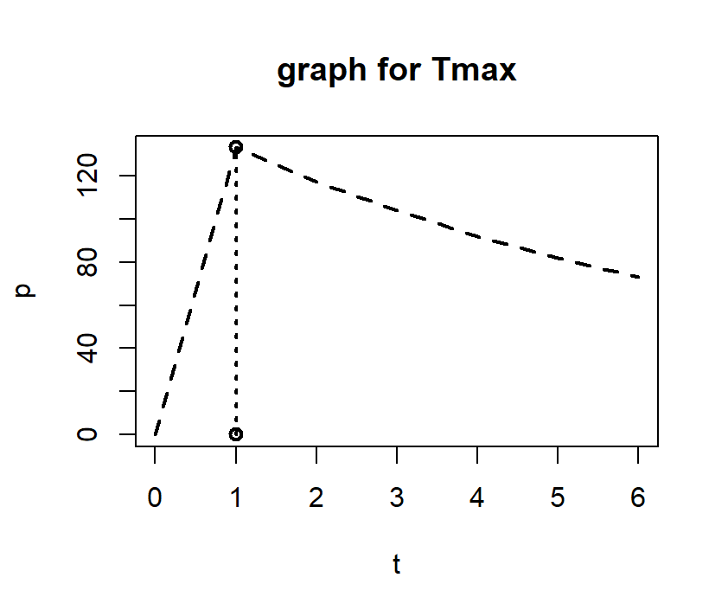

**> # Conclusion : From above plot maximum concentration is Cmax = 133mcg which is at time tmax = 1hr.**

**>**

**> log_p=log10(p)**

**> log_p**

**[1] -Inf 2.123852 2.068186 2.017033 1.963788 1.913814 1.863323**

**> h=lm(log_p[2:7]~t[2:7]);h**

**Call:**

**lm(formula = log_p[2:7] ~ t[2:7])**

**Coefficients:**

**(Intercept) t[2:7]**

**2.17357 -0.05197**

**>**

**> slope=-0.05197**

**>**

**> ke=(-2.303)*(-0.05197) #Rate of elimination**

**> ke**

**[1] 0.1196869**

**>**

**> t_half=0.693/ke #Half-life period of the drug**

**> t_half**

**[1] 5.790107**

**> *###Q2***

**Q.2 For the given data below: Calculate AUC(0-32), AUC(0-∞), Cmax ,tmax ,Ke ,t1/2**

|  |  |
| --- | --- |
| **Time (Hour)** | **Plasma Concetration (mcg/mL** |
| **0** | **0** |
| **0.5** | **0** |
| **1** | **2.8** |
| **1.5** | **4.4** |
| **2** | **4.4** |
| **3** | **4.7** |
| **4** | **4.1** |
| **6** | **4** |
| **8** | **3.6** |
| **12** | **3** |
| **16** | **2.5** |
| **24** | **2** |
| **32** | **1.6** |

**>**

**>**

**> t=c(0,0.5,1,1.5,2,3,4,6,8,12,16,24,32)**

**> c=c(0,0,2.8,4.4,4.4,4.7,4.1,4,3.6,3,2.5,2,1.6)**

**> Cmax = max(c)**

**> Cmax**

**[1] 4.7**

**>**

**> tmax=max(t)**

**> tmax**

**[1] 32**

**> c1 = rep(0,13)**

**> t1 = rep(0,13)**

**> for(i in 1:13)**

**+ {**

**+ if(i == 1)**

**+ {**

**+ c1[i] = c[i]**

**+ }**

**+ else**

**+ {**

**+ c1[i] = (c[i]+c[i-1])/2**

**+ }**

**+ }**

**> c1**

**[1] 0.00 0.00 1.40 3.60 4.40 4.55 4.40 4.05 3.80 3.30**

**[11] 2.75 2.25 1.80**

**>**

**> for(i in 1:13)**

**+ {**

**+ if(i == 1)**

**+ {**

**+ t1[i] = t[i]**

**+ }**

**+ else**

**+ {**

**+ t1[i] = (t[i]-t[i-1])**

**+ }**

**+ }**

**> t1**

**[1] 0.0 0.5 0.5 0.5 0.5 1.0 1.0 2.0 2.0 4.0 4.0 8.0 8.0**

**>**

**> *# AUC for range 0-32***

**> AUC = t1*c1; AUC**

**[1] 0.00 0.00 0.70 1.80 2.20 4.55 4.40 8.10 7.60**

**[10] 13.20 11.00 18.00 14.40**

**> AUC_32 = sum(AUC);AUC_32**

**[1] 85.95**

**> log_c = log10(c)**

**> m = lm(log_c[3:13]~t[3:13]);m**

**Call:**

**lm(formula = log_c[3:13] ~ t[3:13])**

**Coefficients:**

**(Intercept) t[3:13]**

**0.64128 -0.01367**

**> slope =-0.01367**

**> Ke = -2.303*slope;Ke**

**[1] 0.03148201**

**> *# t_half (Half life period of the drug)***

**> t_half = 0.693/Ke;t_half**

**[1] 22.01257**

**> *# AUC for 0-inf***

**> AUC_inf = AUC_32+(c[13]/Ke);AUC_inf**

**[1] 136.7727**

**>**